457.568 Statistical Hydrology, Fall 2022
Quiz #1, Sep-27, 2022 (30 mins, 40 pts total)
Student Number: ___________________ Name: ___________________

I) Multiple Choice Questions (3 pts each, 6 pts total)
- Choose the correct word(s) for the blank in the following sentence:
Among various measures of the central tendencies, _________ can be classified as a reduced measure of central tendency that is less sensitive to outliers.
- the median
- the mode
- correlation coefficient
- arithmetic mean
- both (a) and (b)

- If A and B are statistically independent, then the following holds true:
- P(A|B) = P(A|B)P(B)
- P(A$∩$B) = P(A)P(B)
- P(A$∩$B) = 0
- Both (a) and (b)
- All of the above

II) Short Answers (7 pts each, 14 pts total)
- Chebyshev Inequality can be written as the follows:
$$P\left\{|X-μ|≥kσ\right\}≤\frac{1}{k^{2}}$$
- Briefly explain about the Chebyshev Inequality.
- What is the relationship between the Chebyshev Inequality and the 68-95-99.7 rule applicable in normal distributions? You may include figures during your explanation if it helps you to explain.

- The figure below shows the procedure for transforming nonstandard normal distribution into a standard normal distribution.
The shaded area on the two figures are equal. Fill in the blank for (a) and (b):
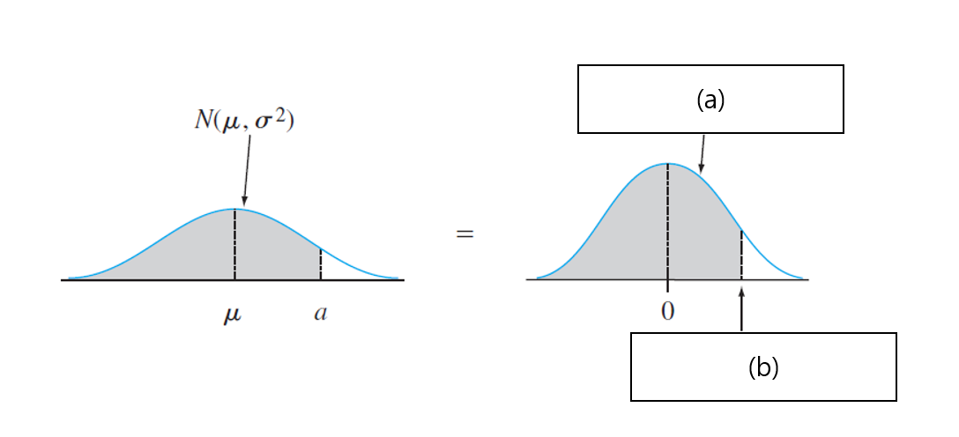

III) Problem Solving (10 pts each, 20 pts total)
- In the United States, approximately 1 in 100 otherwise healthy people has Celiac Disease. A new diagnostic test, has a 95% reliability, i.e., 95% of people with Celiac test positive, and 95% of people without Celiac test negative. During trials, a randomly selected person tests positive.
(a) What is the probability that the person has Celiac Disease?
(b) What is the probability that the person doesn’t?

- Suppose that X is a discrete random variable with the following probability mass function: where $0≤θ≤1$ is a parameter. The following 10 independent observations were taken from such a distribution: (3,0,2,1,3,2,1,0,2,1). What is the maximum likelihood estimate of $θ$ (i.e., ${\hat{θ}}_{MLE}$)? (Hint: $\frac{d}{dx}\ln\left(x\right)=\frac{1}{x}$)
X | 0 | 1 | 2 | 3
P(X) | 2$θ$/3 | $θ$/3 | 2$(1-θ)$/3 | $(1-θ)$/3

